ACTIVITY DIAGRAM
Illustrates the flow from user query to response generation.

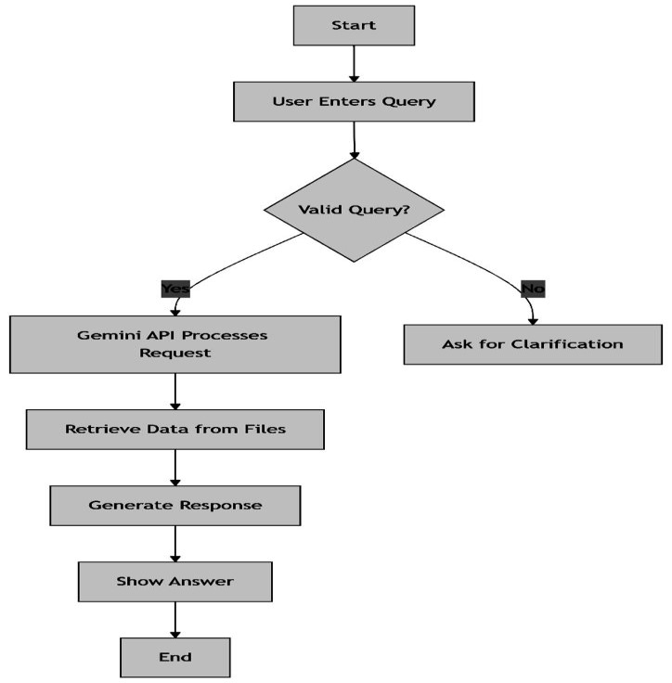

USE CASE DIAGRAM
Illustrates the flow from user query to response generation.
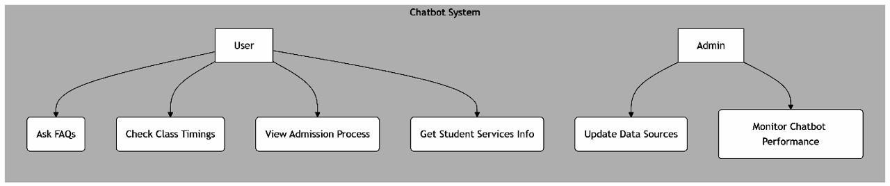

DATA FLOW DIAGRAM
Visualizes how data moves from user input to Gemini API to response.

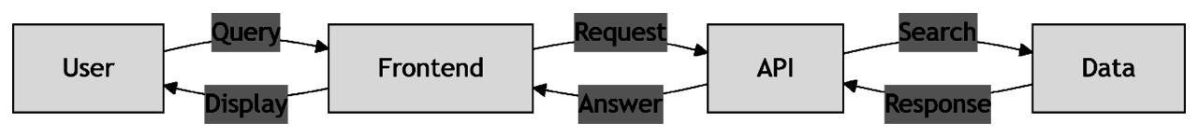

SEQUENCE DIAGRAM
Details the sequence of API calls and data retrieval.
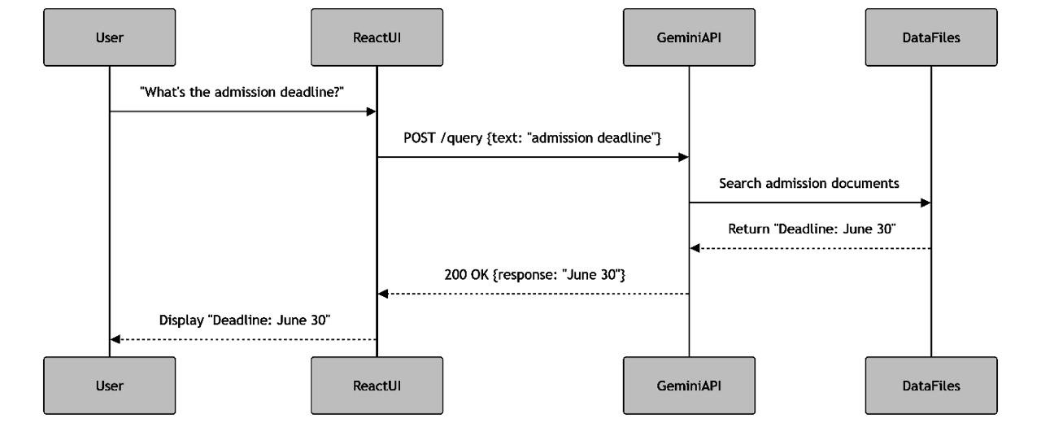

CLASS DIAGRAM
Defines chatbot components and their relationships.
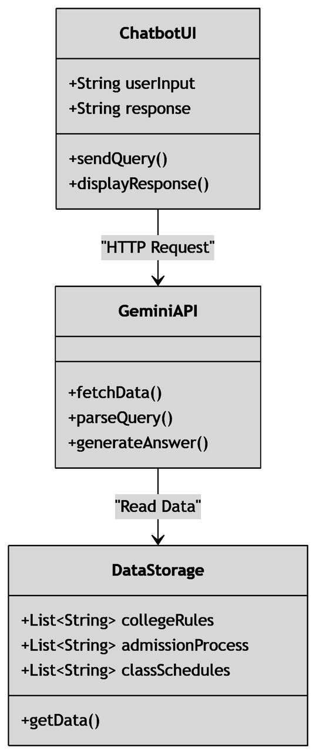

DEPLOYMENT DIAGRAM
Shows hosting setup: web server, API endpoint, document storage.

STATE DIAGRAM
Represents chatbot states during a session.
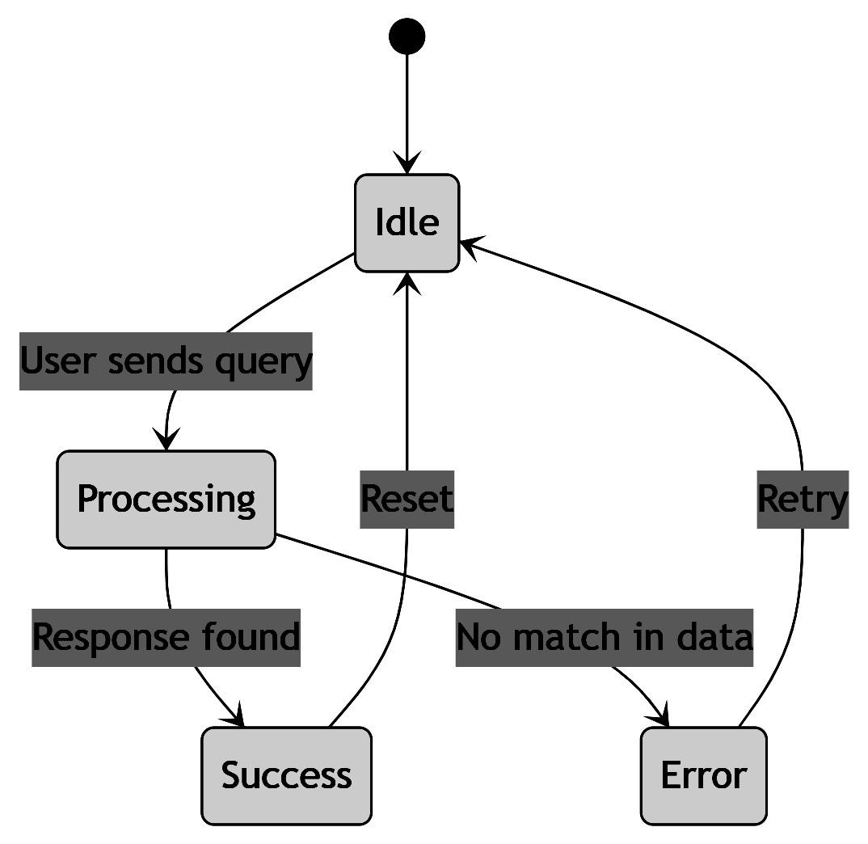

COMPONENT DIAGRAM
Outlines modular structure: UI, API, data handler.
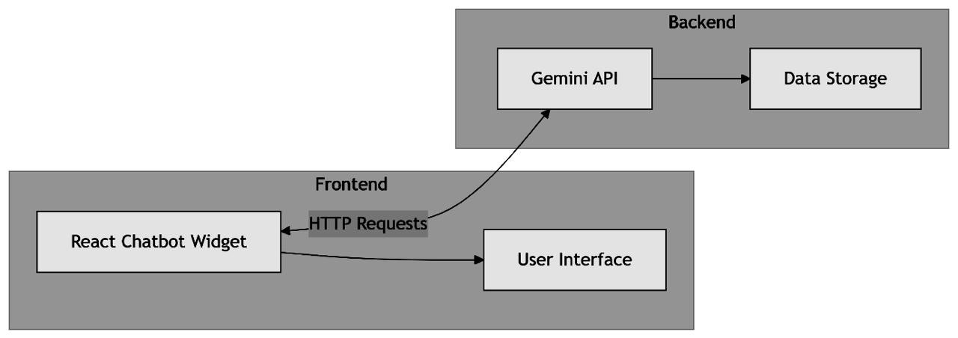

SYSTEM ARCHITECTURE
The chatbot uses a modular architecture with a React frontend for user interaction and a Gemini API backend that retrieves information from predefined data sources without modifying it. This setup ensures real-time responses and easy scalability, allowing new features or data to be added with minimal changes.

